Heart Attack – Signs and Symptoms

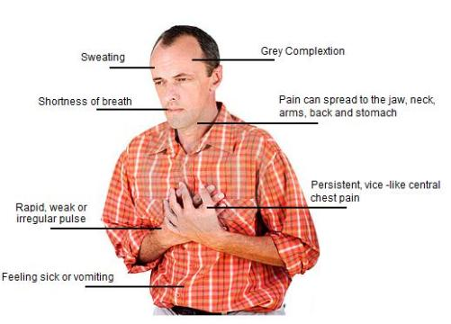*“Women may have different signs and symptoms for heart attack from men. However, chest pain or pressure is the most common symptom of a heart attack for both genders”*

Signs and Symptoms

|  |  |
| --- | --- |
| Women | Men |
| Symptoms of a heart attack that women feel may include:   * + 1. Chest pain or discomfort. Chest pain is the most common heart attack symptom. It may feel like uncomfortable pressure, squeezing, fullness or pain in the center of your chest that lasts more than a few minutes, or goes away and comes back.     2. Some women may experience heart attack symptoms differently than men. Women may experience jaw pain or back pain in the area across the shoulder blades (*i.e.*, along the bra line).     3. Heart attack symptoms in women may also include pain or discomfort in the stomach including nausea or vomiting,     4. Pain or discomfort in one or both arms or neck.     5. Breaking out in a cold sweat or lightheadedness.     6. Shortness of breath or fatigue.     7. no symptoms (approximately one quarter of all heart attacks are silent, without chest pain or new symptoms and silent heart attacks are especially common among patients with [diabetes mellitus](http://www.medicinenet.com/script/main/art.asp?articlekey=343)). | Symptoms of a heart attack that men feel may include:   1. Chest pain or pressure, fullness, and/or squeezing sensation of the chest. Chest pain is the most common heart attack symptom. It may feel like uncomfortable pressure, squeezing, fullness or pain in the center of your chest that lasts more than a few minutes, or goes away and comes back. 2. Some men may experience jaw pain, toothache, headache; 3. shortness of breath; 4. nausea, vomiting, or general stomach discomfort; 5. sweating; 6. heartburn or indigestion; 7. arm pain (more commonly the left arm, but may be either arm); 8. general malaise (vague feeling of illness); and 9. no symptoms (approximately one quarter of all heart attacks are silent, without chest pain or new symptoms and silent heart attacks are especially common among patients with [diabetes mellitus](http://www.medicinenet.com/script/main/art.asp?articlekey=343)). |

What to do next

**If you have any of these signs, don’t wait more than five minutes before calling for help. Call 9-1-1 and get to a hospital right away.**

Even though the symptoms of a heart attack at times can be vague and mild, it is important to remember that heart attacks producing no symptoms or only mild symptoms can be just as serious and life-threatening as heart attacks that cause severe chest pain. Too often patients attribute heart attack symptoms to "indigestion," "[fatigue](http://www.medicinenet.com/script/main/art.asp?articlekey=9879)," or "[stress](http://www.medicinenet.com/script/main/art.asp?articlekey=488)," and consequently delay seeking prompt medical attention. The importance of seeking prompt medical attention in the presence of symptoms that suggest a heart attack cannot be overemphasize. Early diagnosis and treatment saves lives, and delays in reaching medical assistance can be fatal. A delay in treatment can lead to permanently reduced function of the heart due to more extensive damage to the heart muscle.

We’ve all seen the movie scenes where a man gasps, clutches his chest and falls to the ground. In reality, a heart attack victim could easily be a woman, and the scene may not be that dramatic.

Although men and women can experience chest pressure that feels like “an elephant sitting across the chest,” women can experience a heart attack without chest pressure. Even though [heart disease](http://www.heart.org/HEARTORG/Conditions/More/MyHeartandStrokeNews/Coronary-Artery-Disease---Coronary-Heart-Disease_UCM_436416_Article.jsp) is the No. 1 killer of women, women often think the symptoms indicate less life-threatening conditions like acid reflux, the flu or normal aging.

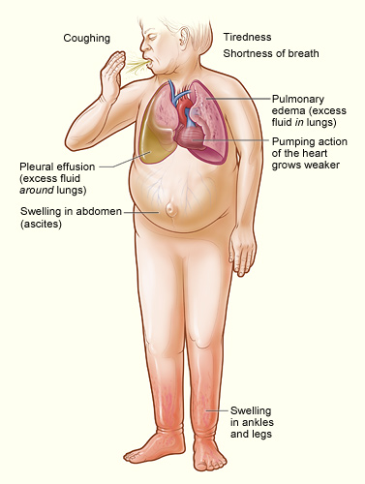Heart Failure – Signs and Symptoms

The most common signs and symptoms of heart failure are:

* Shortness of breath or trouble breathing
* Fatigue (tiredness)
* Swelling in the ankles, feet, legs, abdomen, and veins in the neck

All of these symptoms are the result of fluid buildup in your body. When symptoms start, you may feel tired and short of breath after routine physical effort, like climbing stairs.

As your heart grows weaker, symptoms get worse. You may begin to feel tired and short of breath after getting dressed or walking across the room. Some people have shortness of breath while lying flat.

Fluid buildup from heart failure also causes weight gain, frequent urination, and a cough that's worse at night and when you're lying down. This cough may be a sign of acute pulmonary edema (e-DE-ma). This is a condition in which too much fluid builds up in your lungs. The condition requires emergency treatment.

Heart Failure - Prevention

You can take steps to prevent heart failure. The sooner you start, the better your chances of preventing or delaying the condition.

**For People Who Have Healthy Hearts**

If you have a healthy heart, you can take action to prevent heart disease and heart failure. To reduce your risk of heart disease:

* Follow a healthy diet. A healthy diet includes a variety of vegetables and fruits. It also includes whole grains, fat-free or low-fat dairy products, and protein foods. A healthy diet is low in sodium (salt), added sugars, solid fats, and refined grains.
* If you smoke, make an effort to quit. Talk with your doctor about programs and products that can help you quit smoking. Also, try to avoid secondhand smoke.
* If you're overweight or obese, try to lose weight. Work with your health care team to create a reasonable weight-loss plan.
* Be physically active. People gain health benefits from as little as 60 minutes of moderate-intensity aerobic activity per week. The more active you are, the more you will benefit.
* Avoid using illegal drugs.
* Avoid chronic stress.

**For People Who Are at High Risk for Heart Failure**

Even if you're at high risk for heart failure, you can take steps to reduce your risk. People at high risk include those who have coronary heart disease, high blood pressure, or diabetes.

* Follow all of the steps listed above. Talk with your doctor about what types and amounts of physical activity are safe for you.
* Treat and control any conditions that can cause heart failure. Take medicines as your doctor prescribes.
* Avoid drinking alcohol.
* Avoid chronic stress.
* See your doctor for ongoing care.

**For People Who Have Heart Damage but No Signs of Heart Failure**

If you have heart damage but no signs of heart failure, you can still reduce your risk of developing the condition. In addition to the steps above, take your medicines as prescribed to reduce your heart's workload.